

SINDH MADRESSATUL ISLAM UNIVERSITY (SMIU) DEPARTMENT OF SOFTWARE ENGINEERING(SE)

FALL 2026

COURSE TITLE: INTRODUCTION TO DATA SCIENCE
SEMESTER/SECTION: BSSE 6B
COURSE CODE: CSC 218
INSTRUCTOR: MS. LARAIB WAHEED

Lab 5
Pandas with Data Visualization

Objective
Visualizing Data using Pandas, Matplotlib.
To learn how to use Pandas with visualization libraries Matplotlib to analyze and represent data graphically.

Introduction:
In data analysis, we often deal with large sets of numbers that are hard to understand by just looking at tables.
Visualization converts those numbers into graphs and charts, which makes it easier to:
- Identify patterns and trends
- Compare categories
- Spot outliers or unusual data
- Present data more clearly to others
In Python, the three most common libraries for visualization are:
- Pandas Visualization – Quick and simple plotting using .plot()
- Matplotlib – The most powerful and flexible graphing library
- Seaborn – Built on Matplotlib, gives colorful and attractive statistical charts

1. Pandas Visualization
Pandas has a built-in function .plot() that uses Matplotlib internally.
You can make quick plots directly from your DataFrame without importing Matplotlib separately.
Example:
df['Total_Sales'].plot(kind='bar')
Advantages:
- Very quick and simple
- Good for small datasets or when testing code
- Works directly with DataFrame columns
2. Matplotlib
Matplotlib is the base library for visualization in Python.
It gives complete control over how your graphs look — color, size, labels, grid, etc.
Common functions include:
- plt.bar() – Creates a bar chart
- plt.plot() – Creates a line graph
- plt.scatter() – Creates a scatter plot
Each graph can be customized using:
- plt.title() → Adds a title
- plt.xlabel() / plt.ylabel() → Labels axes
- plt.xticks(rotation=45) → Rotates category names
import matplotlib.pyplot as plt

Example:
plt.bar(df['Product'], df['Total_Sales'])
plt.title("Sales by Product")
plt.xlabel("Product")
plt.ylabel("Total Sales")
plt.show()
In a store, a manager can quickly see which product has highest sales using this chart.
Task 1 – Using Pandas Visualization
Create a bar chart using Pandas to show Total Sales per Product.
df.plot(x='Product', y='Total_Sales', kind='bar', title='Total Sales by Product')
What to Observe: Which product made the highest sales.

Create a line chart to show Category vs Total Sales and label it properly.
import matplotlib.pyplot as plt

plt.plot(df['Category'], df['Total_Sales'], marker='o')
plt.title("Sales by Category")
plt.xlabel("Category")
plt.ylabel("Total Sales")
plt.grid(True)
plt.show()
What to Observe: Compare sales across different categories.
- Visualization using Pandas:

Bar Chart – Total Sales by Product
df.plot(x='Product', y='Total_Sales', kind='bar', title='Total Sales by Product')
Purpose: Compare sales of different products

Pie Chart – Sales Share by Category
df.groupby('Category')['Total_Sales'].sum().plot(
kind='pie',
autopct='%1.1f%%',
startangle=90,
title='Sales Percentage by Category',
ylabel=''
)
Purpose: Show percentage contribution

Line Chart – Sales Trend
df.plot(x='Product', y='Total_Sales', kind='line', marker='o', title='Sales Trend by Product')
Purpose: Show trends over products

Histogram – Sales Distribution
df['Total_Sales'].plot(kind='hist', bins=5, title='Sales Distribution')
Purpose: Understand data distribution

Scatter Plot – Price vs Sales
df.plot(kind='scatter', x='Unit_Price', y='Total_Sales', title='Price vs Sales')
Purpose: Analyze relationship between variables

Visualization using Matplotlib
Import required library:
import matplotlib.pyplot as plt

1. Bar Chart
plt.bar(df['Product'], df['Total_Sales'])
plt.title("Total Sales by Product")
plt.xlabel("Product")
plt.ylabel("Total Sales")
plt.xticks(rotation=45)
plt.show()

2. Pie Chart
category_sales = df.groupby('Category')['Total_Sales'].sum()
plt.pie(category_sales, labels=category_sales.index, autopct='%1.1f%%', startangle=90)
plt.title("Sales Percentage by Category")
plt.show()

3. Line Chart
plt.plot(df['Product'], df['Total_Sales'], marker='o')
plt.title("Sales Trend by Product")
plt.xlabel("Product")
plt.ylabel("Total Sales")
plt.grid(True)
plt.show()

4. Histogram
plt.hist(df['Total_Sales'], bins=5)
plt.title("Sales Distribution")
plt.xlabel("Sales Range")
plt.ylabel("Frequency")
plt.show()

5. Scatter Plot
plt.scatter(df['Unit_Price'], df['Total_Sales'])
plt.title("Price vs Sales")
plt.xlabel("Unit Price")
plt.ylabel("Total Sales")
plt.show()

Task 1: Pandas Visualization
Using Pandas .plot():
- Create a Bar Chart for Product vs Total Sales
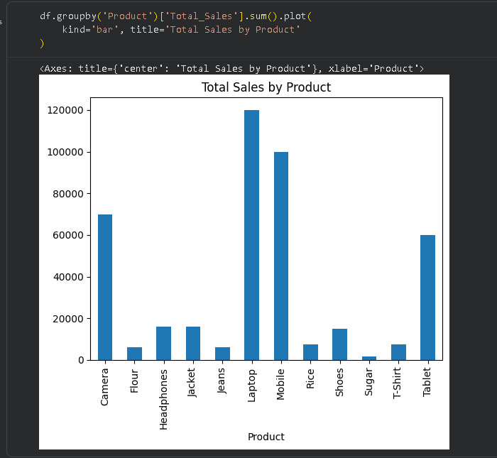
- Create a Line Chart for Sales Trend
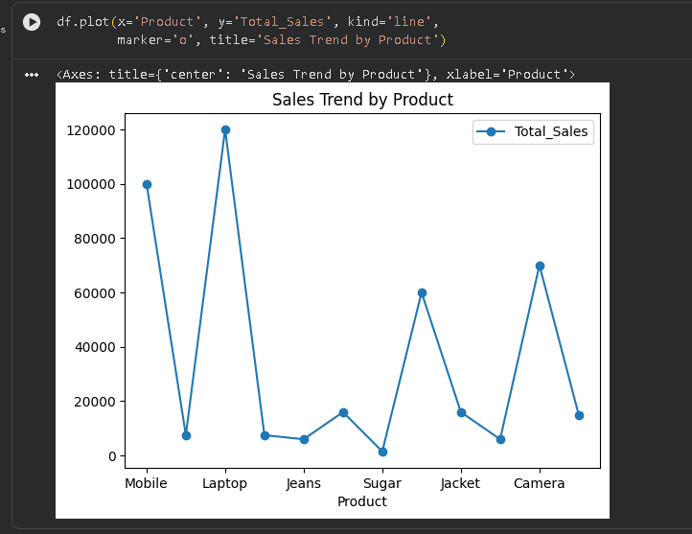
- Create a Pie Chart for Category-wise Sales
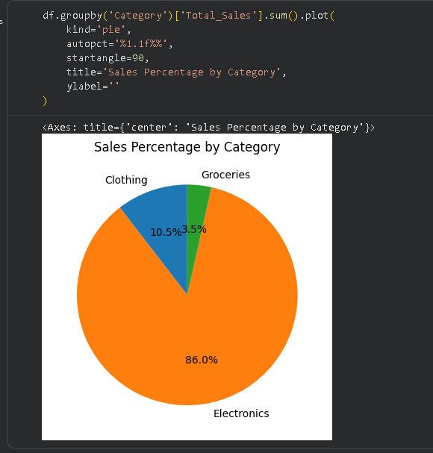
Answer following Questions:
- Which product has the highest sales?
Ans: Laptop, with total sales of 120,000.
- Which category contributes the most?
Ans: Electronics, with total sales of 366,000.
- Is there any trend in sales?
Ans: Sales fluctuate significantly, with peaks for Laptop and Mobile sales.
- What does the histogram show about distribution?
Ans: Sales fluctuate significantly, with peaks for Laptop and Mobile sales.
- Is there a relationship between price and sales?
Ans: Yes, there is a strong positive relationship (correlation ≈ 0.94). Higher unit prices are associated with higher total sales in this dataset.

Task 2: Matplotlib Visualization
Repeat all the above charts using Matplotlib:
- Bar Chart
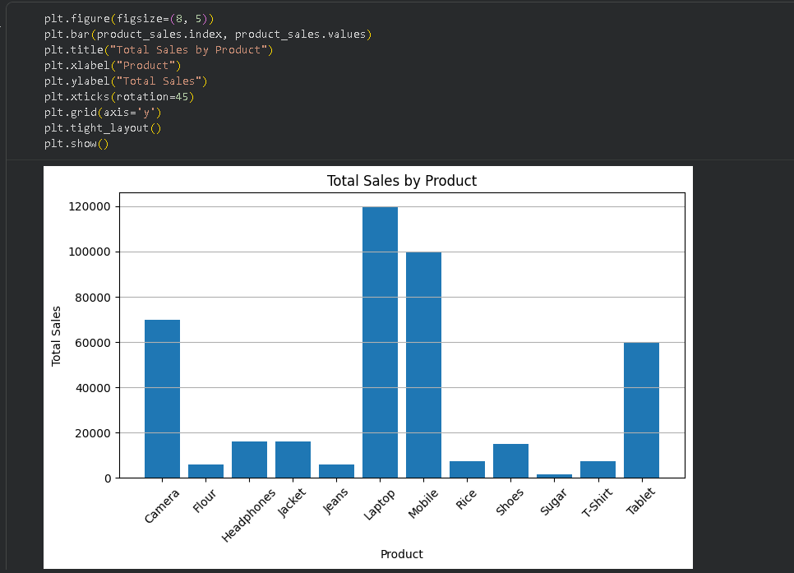

- Line Chart
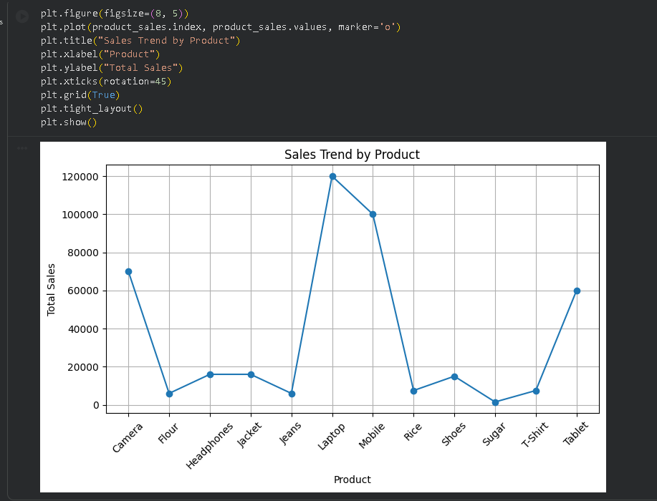
- Pie Chart
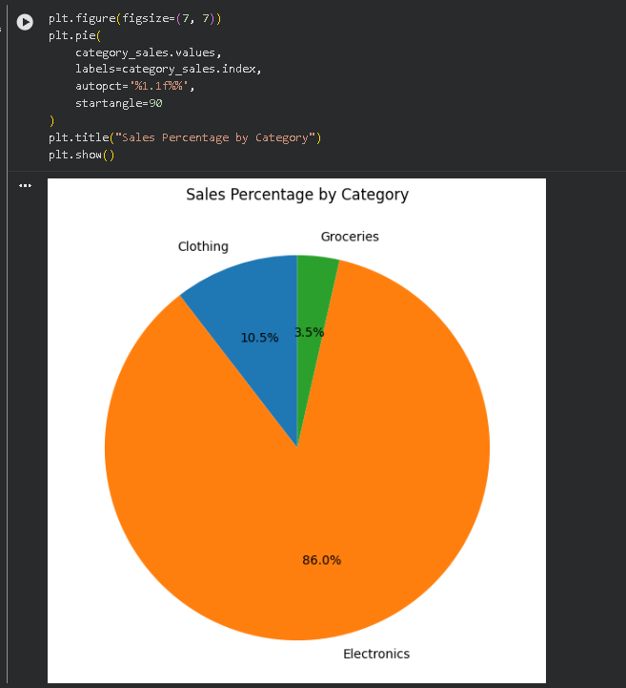
Additional Requirements:
- Add title, labels, and grid where applicable
- Rotate x-axis labels if needed
- Make charts readable and clean

